Main.asm

; Demonstrate the AddTwo Procedure (AddTwo.asm)

; Demonstrates different procedure call protocols.

INCLUDE AddTwo.inc

.data

word1 WORD 1234h

word2 WORD 4111h

sum DWORD ?

.code

main PROC PUBLIC

;call Example1

;call Example2

movzx eax,word1

push eax

movzx eax,word2

push eax

call AddTwo

;call DumpRegs

invoke ExitProcess, 0

main ENDP

END main

AddTwoProc.asm:

; Demonstrate the AddTwo Procedure (AddTwo.asm)

; Demonstrates different procedure call protocols.

INCLUDE AddTwo.inc

.code

AddTwo PROC

; Adds two integers, returns sum in EAX.

; The RET instruction cleans up the stack.

push ebp

mov ebp,esp

mov eax,[ebp + 12] ; first parameter

add eax,[ebp + 8] ; second parameter

pop ebp

mov sum, eax

ret 8 ; clean up the stack

AddTwo ENDP

END

AddTwo.inc

.386

.model flat,stdcall

.stack 4096

ExitProcess PROTO, dwExitCode:DWORD

OPTION PROC:PRIVATE

AddTwo PROTO

EXTERNDEF sum:DWORD

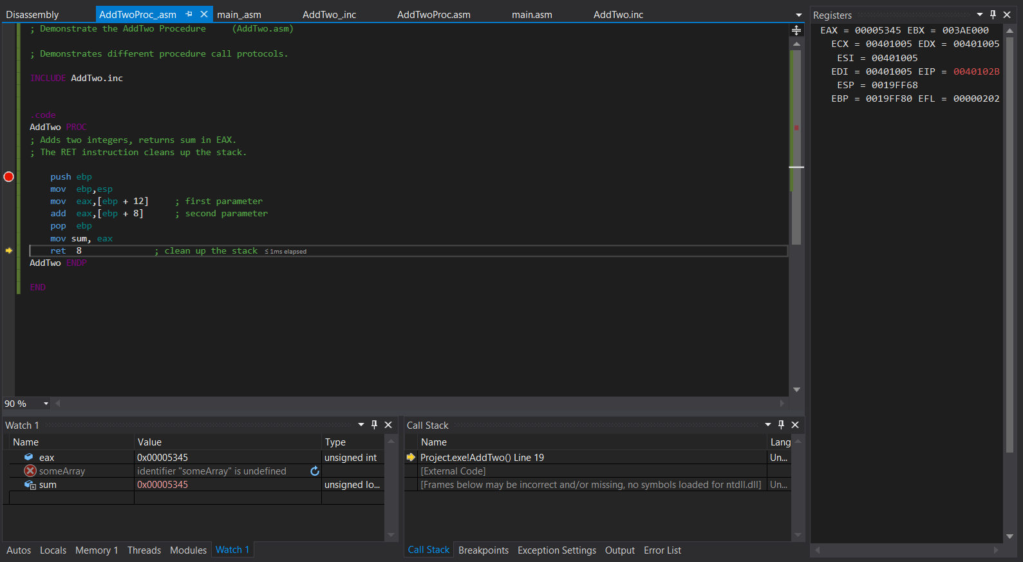

Active debugging session in the Procedure